Faculty Hiring Prioritization Tool

Department/Division

Dean

Number of Positions Requested

EQUITY CONSIDERATIONS

- In the last five years, what is the trend in student success achievement gap between targeted and non-targeted student groups in this program? (example chart)

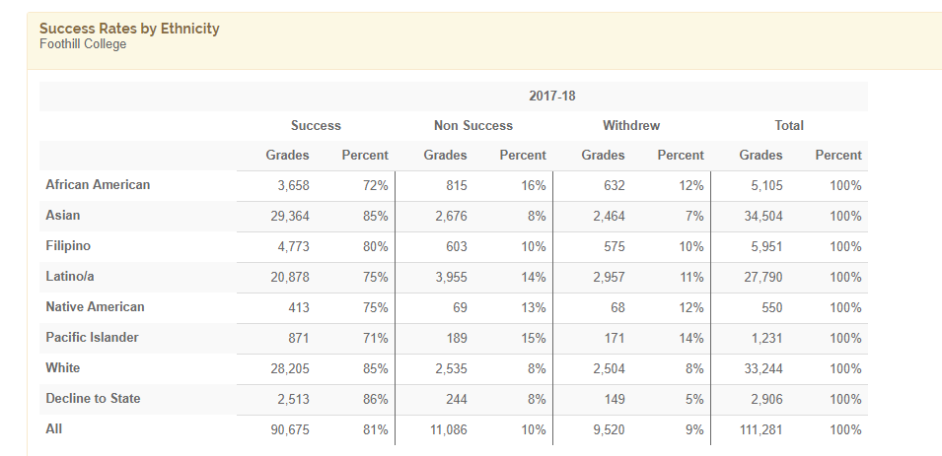

- In the last five years, what is the number of Honors course offerings in the program?

Academic Year | # of Honors Sections
2017-18
2016-17
2015-16
2014-15
2013-14

- In the last five years, what is the percentage change in Dual Enrollment offerings in the program?

Academic Year | # of Dual Enrollment Sections
2017-18
2016-17
2015-16
2014-15
2013-14

- Does the program have any collaborations with any of the learning communities on campus and if so, list those here?

- Does the program offer any interdisciplinary curriculum? If yes, list the courses here?

- Has the program been engaged in creating and or revising course content, curriculum, or pedagogy to offer culturally relevant classroom experiences? If so, list examples here.

- What is the demographic and gender of the Full-Time faculty in this program? (Give percentages in each category).

Ethnicity | Percentage
White
Asian
Latinx
Filipinx
African American
Pacific Islander
Native American
Other

Gender | Percentage
Male
Female
Non-binary

- What is the ratio of Full-Time to Part-Time faculty in the program for the last five years?

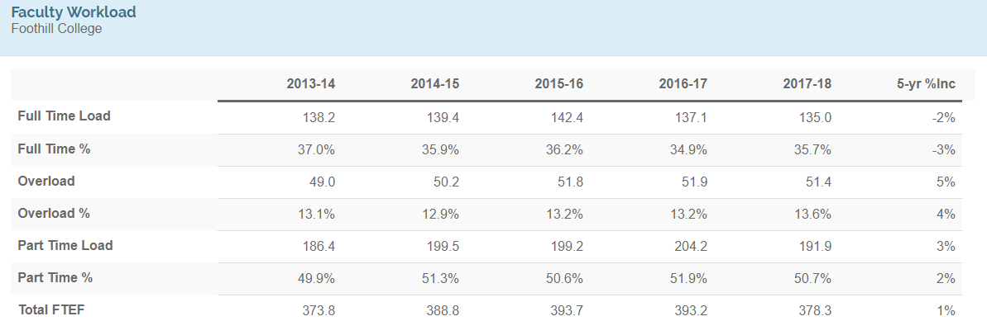

- If you are approved for a new position, please explain what steps you would take to increase the diversity among faculty in your program (e.g., marketing, outreach, specific conferences to promote/interview).

ENROLLMENT CONSIDERATIONS

- What are the enrollment trends for the program over the last five years? (example chart)

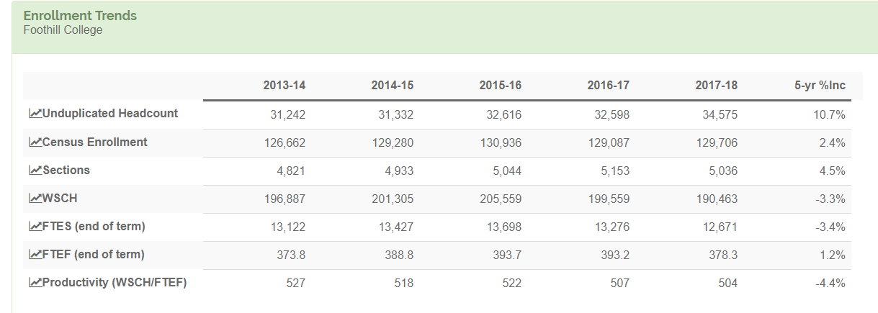

- In the last five years, what is the percentage change in fully online (no hybrid) WSCH in the program?

Academic Year | Increase in WSCH
2017-18
2016-17
2015-16
2014-15
2013-14

- What is the 1320 budget for the program in the last five years?

Academic Year | 1320 Cost
2017-18
2016-17
2015-16
2014-15
2013-14

- In the last five years, what has been the total cost of the program?

Academic Year | Program Costs
2017-18
2016-17
2015-16
2014-15
2013-14

- In the last five years, how many students received an Associate’s degree or a transcribable certificate from this program?

Academic Year | 2017-18 | 2016-17 | 2015-16 | 2014-15 | 2013-14
# of Associates Degrees
# of Transcriptable Certificates

- Please describe how this program supports the overall general completion rates of the college or specific programs.

- Has the program experienced a need for additional section offerings based on waiting list data? If so, explain.

- Has the program experienced personnel or other changes leading to a void in subject matter expertise? If so, explain.

- If this is a CTE program: what is the trend in wages for graduates of the program, in the last five years?

Academic Year | Wages for Graduates
2017-18
2016-17
2015-16
2014-15
2013-14

SERVICE LEARNING CONSIDERATIONS

- List the Service Learning projects that the program faculty engaged in during the last year.

- How does the program plan to engage with Service Learning in the coming years?

